# **Question 1: Plagiarism Checker**

1. Created a directory structure as instructed.

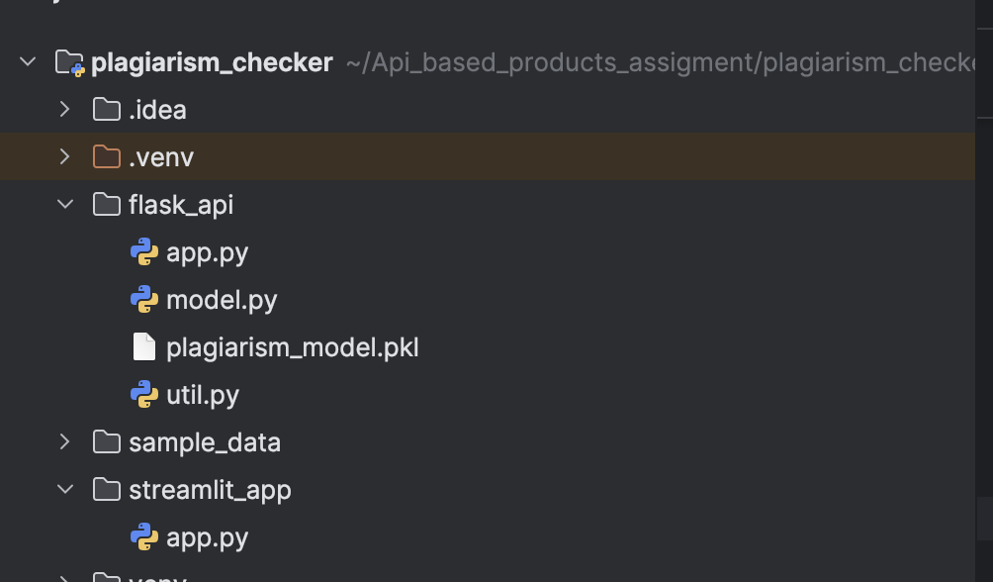

1. Run the following command **streamlit run streamlit_app/app.py** to start the application using streamlit
2. Then follow the URL displayed after starting the application to see the below UI screen.

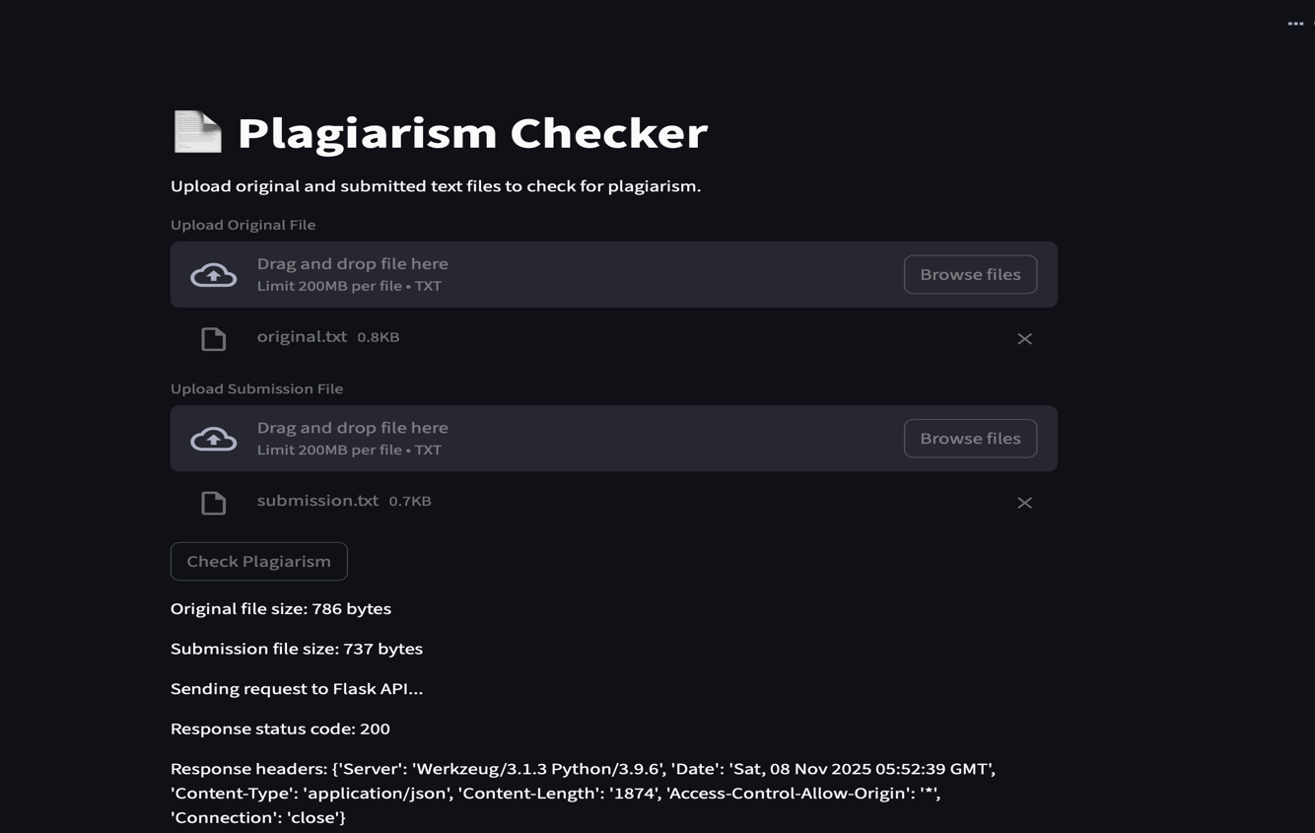

1. Upload your original file and the file that you wanted to check for plagiarism and click on check plagiarism.
2. Now this this will call your Flask API which will return the result with appropriate status codes and responses.

## **Example: Below image displays the output from the flask end point**

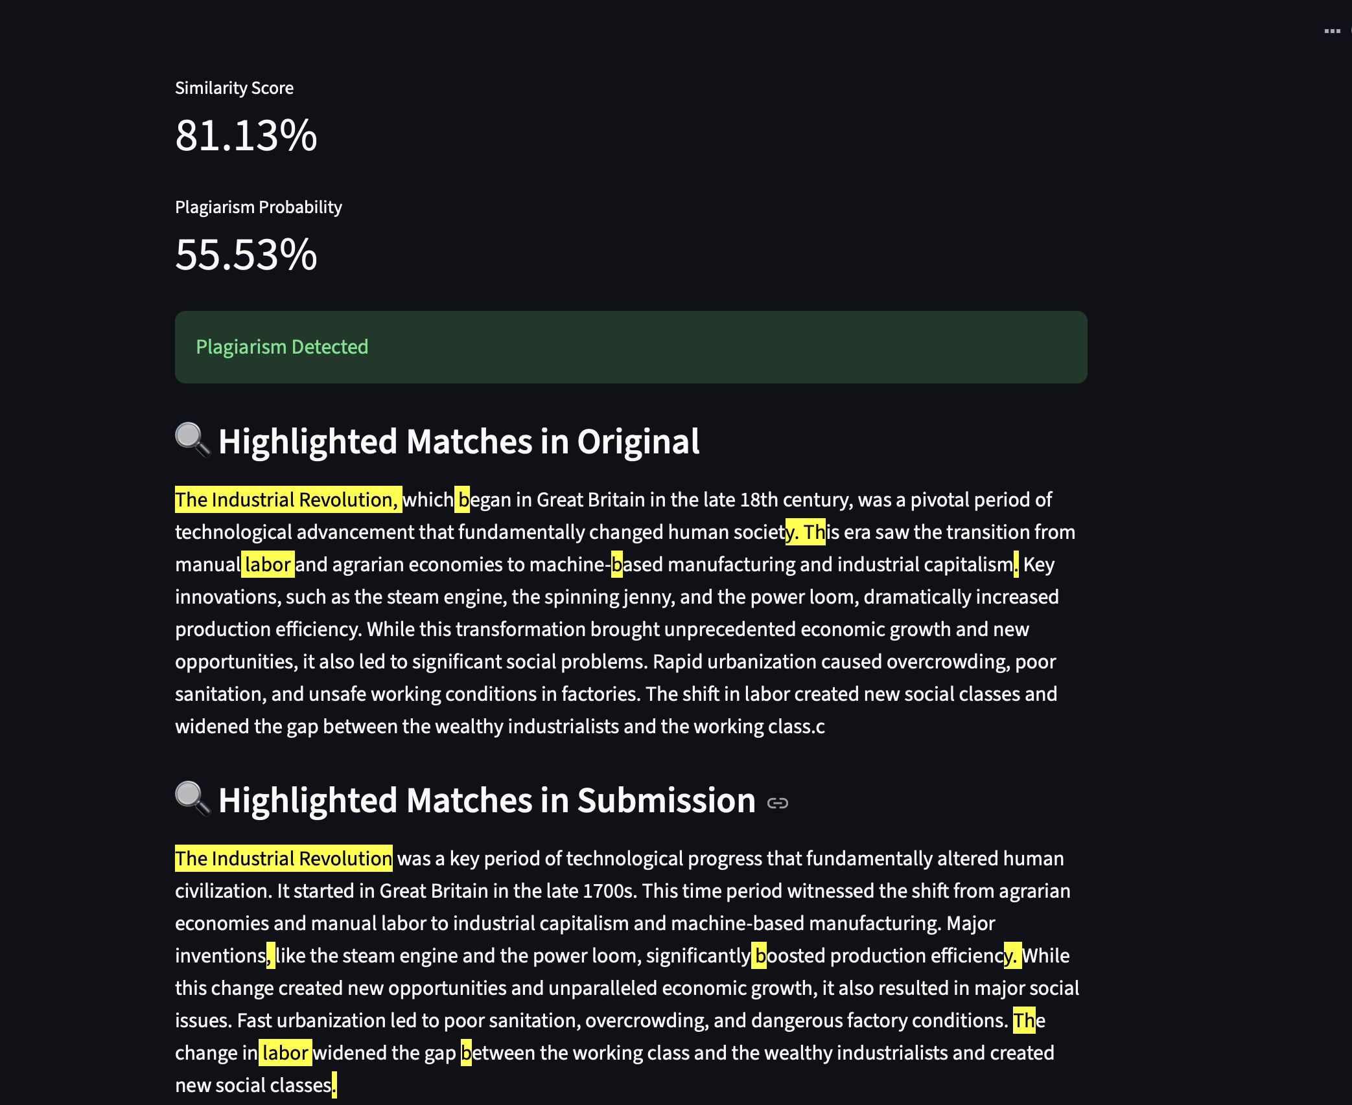

# **Question 2: Perform rate limiting and request size limiting with KONG API Gateway. Step:1 Install a docker desktop and open docker and type in command prompt/ terminal to see if docker is installed successfully or not as below image.**

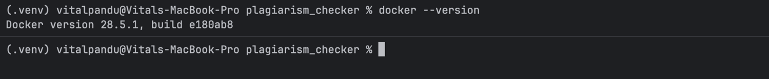

## **Step 2: Now create a docker-compose.yml in our project with the following code.**

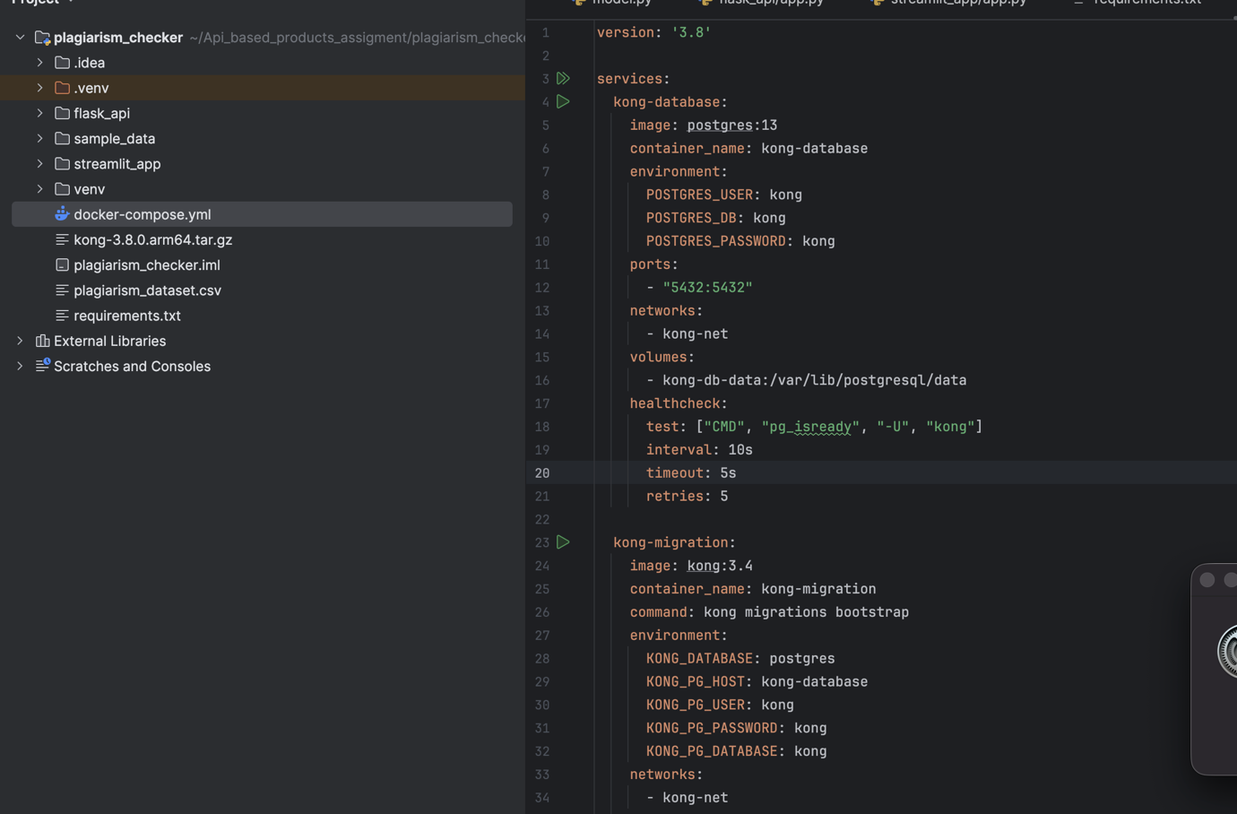

## **Step 3: Use the below commands to start docker using docker-compose.yml.**

*# Start all services*

docker-compose up -d

*# Check if all containers are running*

docker-compose ps

*# View logs*

 docker-compose logs -f kong

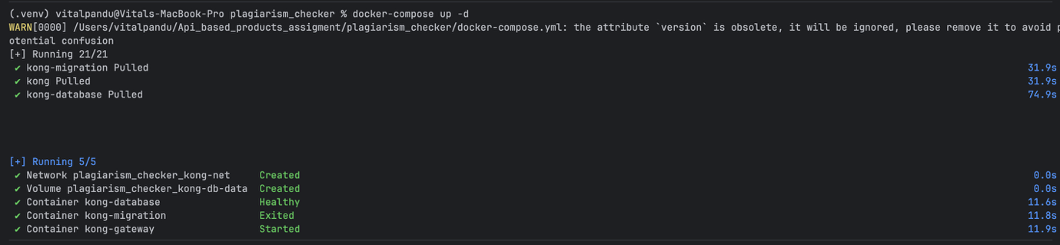

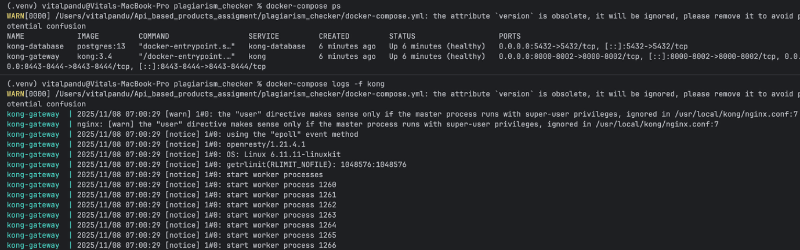

## **Step 4: To verify Kong is Up and running run the below command.**

curl -i <http://localhost:8001/>

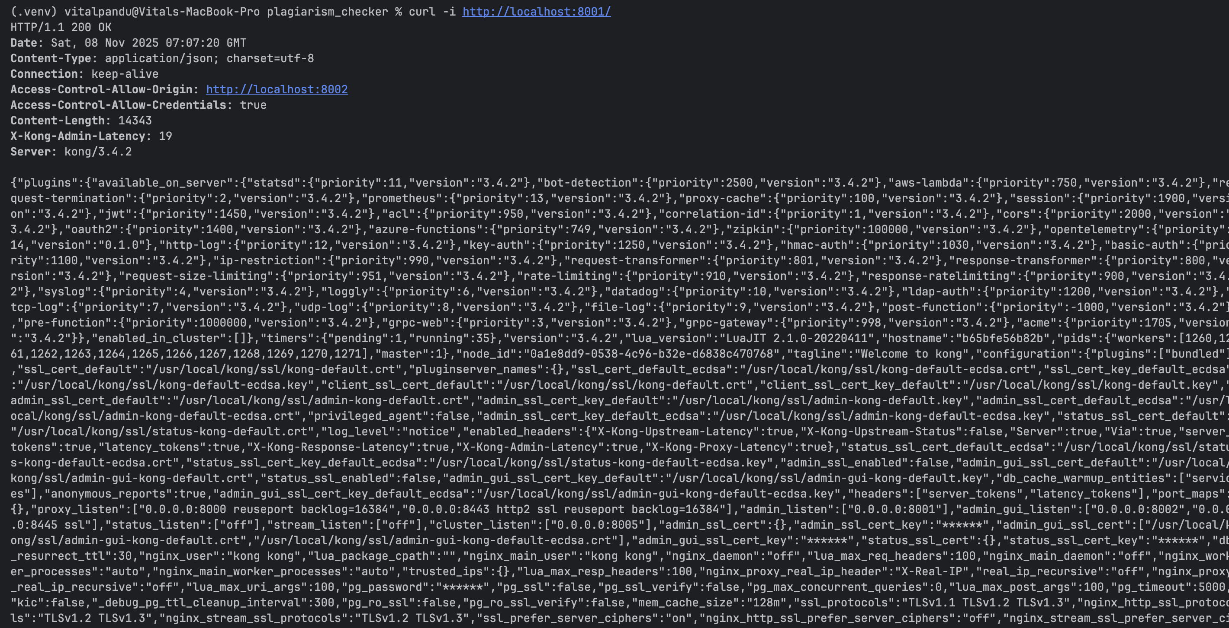

Or got to browser and type in <http://localhost:8001/> and <http://localhost:8002/> in URL address bar to see Kong admin page

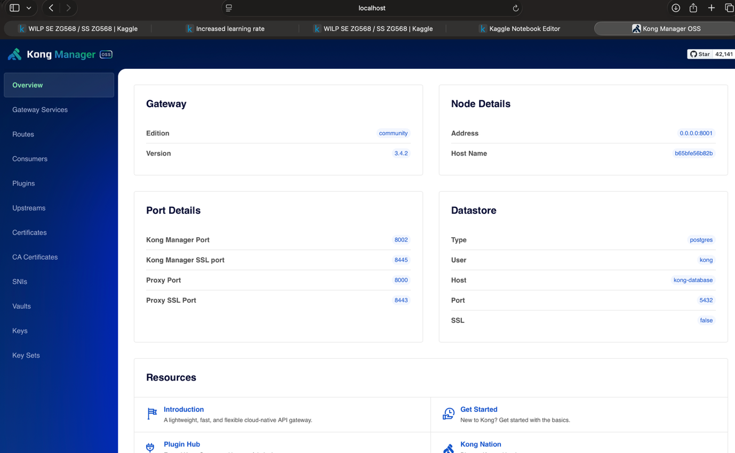

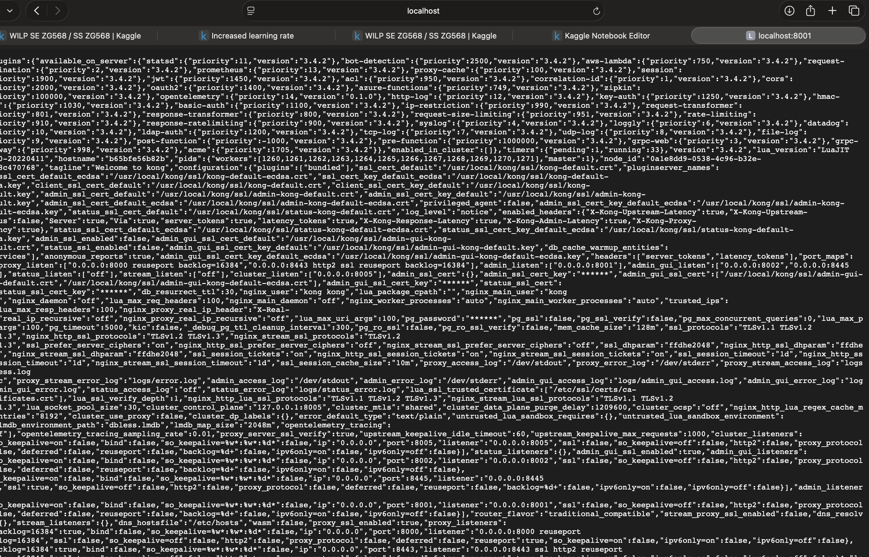

## **Step 5: Start my flask app using following command**

**python flask_api/app.py**

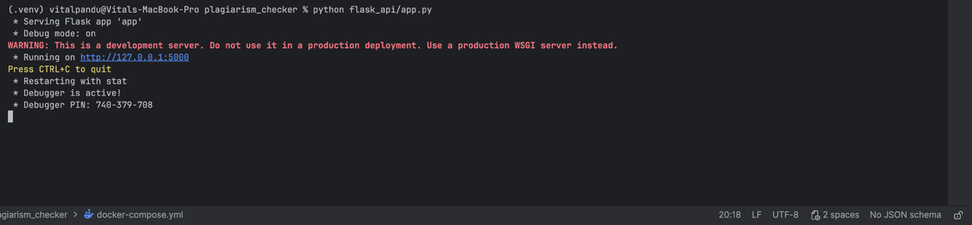

## **Step 6: Now register our api with Kong using below commands.**

# Create a service

curl -i -X POST http://localhost:8001/services/ \

--data "name=plagiarism-api" \

--data "url=http://host.docker.internal:5000"

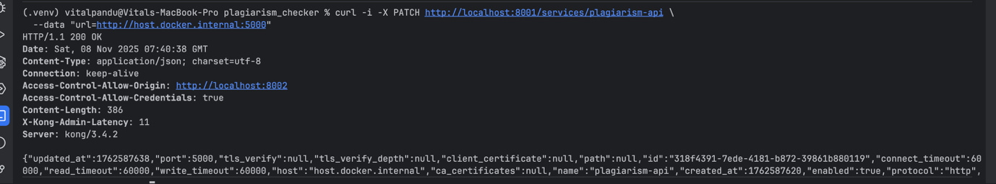

## **Step 7: Create a route using below commands.**

# Create a route

curl -i -X POST http://localhost:8001/services/plagiarism-api/routes \

--data "name=plagiarism-route" \

--data "paths[]=/api/plagiarism" \

--data "strip_path=true"

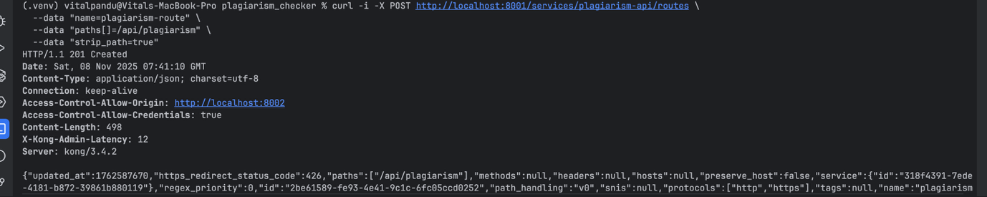

## **Step 8: Test the routes.**

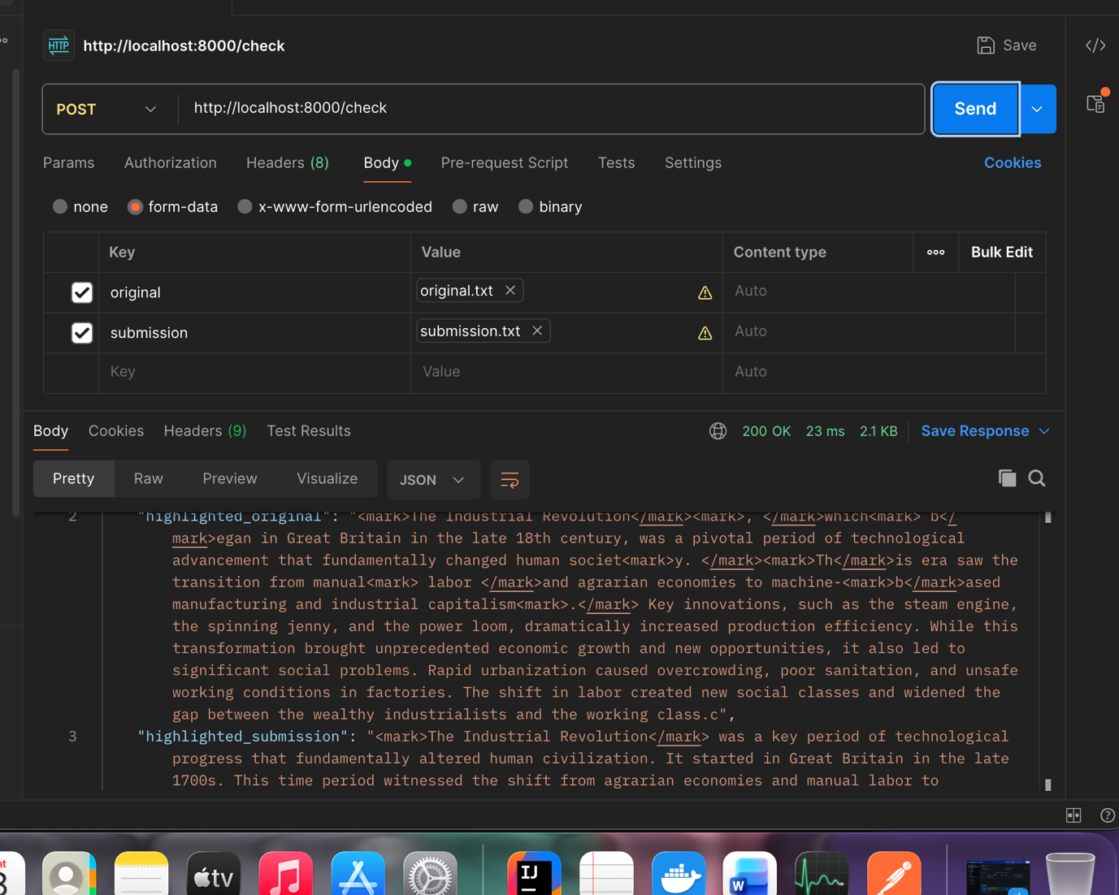

## **Step 9: Now enable rate limiting plugin using below command.**

# Add rate limiting (10 requests per minute, 100 per hour)

curl -i -X POST http://localhost:8001/services/plagiarism-api/plugins \

--data "name=rate-limiting" \

--data "config.second=5" \

--data "config.minute=10" \

--data "config.hour=100" \

--data "config.policy=local" \

--data "config.fault_tolerant=true" \

--data "config.hide_client_headers=false"

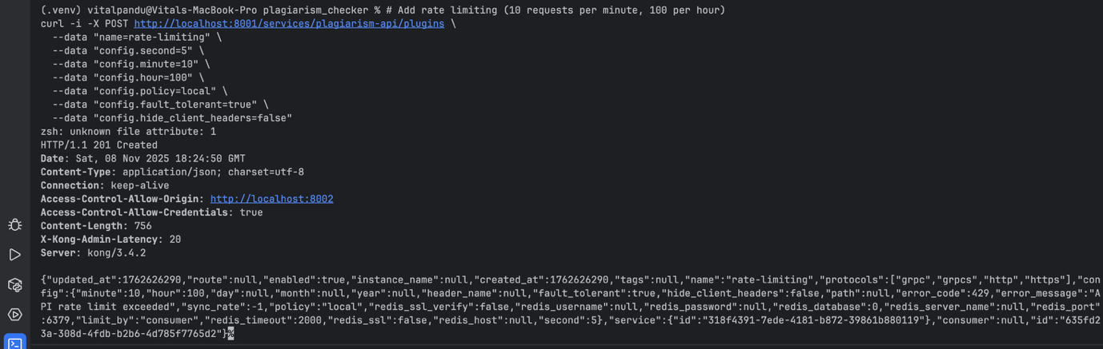

## **Step 10: Enabling Request file size limit using below command.**

# Limit request size to 10MB

curl -i -X POST http://localhost:8001/services/plagiarism-api/plugins \

--data "name=request-size-limiting" \

--data "config.allowed_payload_size=10" \

--data "config.size_unit=megabytes" \

--data "config.require_content_length=true"

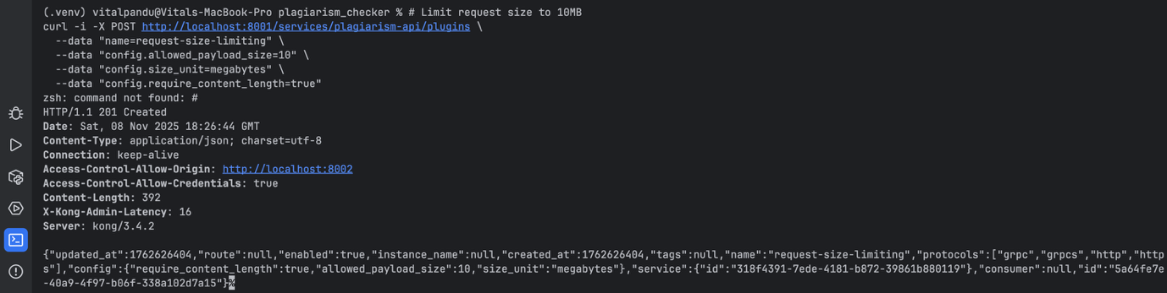

## **Step 11: Verifying add plugins like, Rate Limiting and Request Size Limit are active or not using below command.**

# List all plugins

curl -s http://localhost:8001/services/plagiarism-api/plugins | python3 -m json.tool

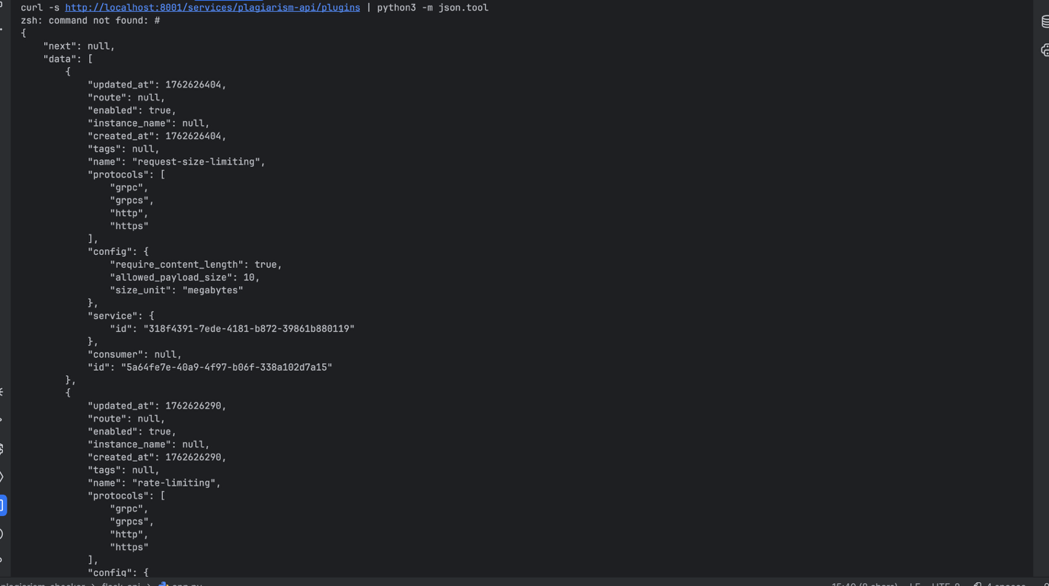

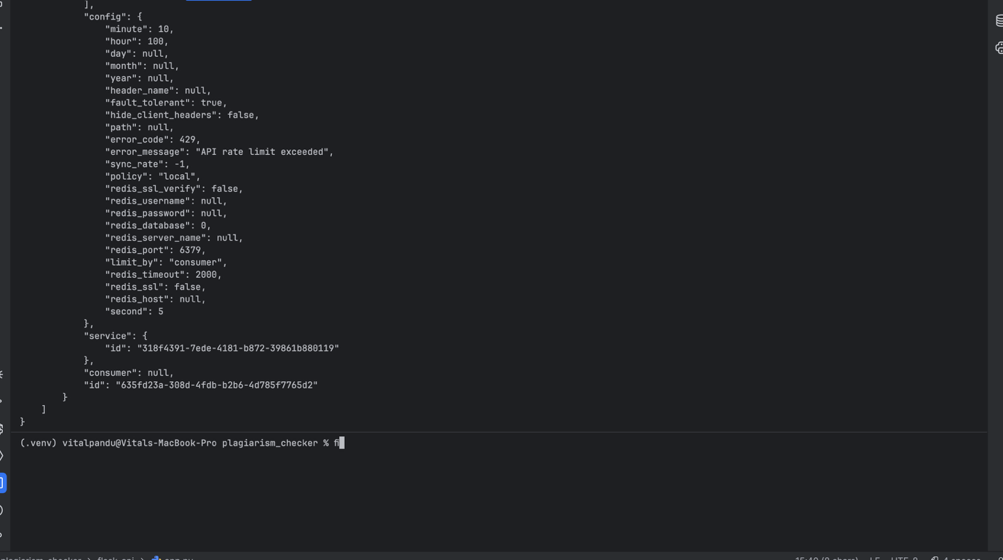

## **Step 12: Now test the api to see rate limiting.use postman Runner to send requests to API.**

So the limits are:

* **5 requests per second**
* **10 requests per minute**
* **100 requests per hour**

Rate Limit.

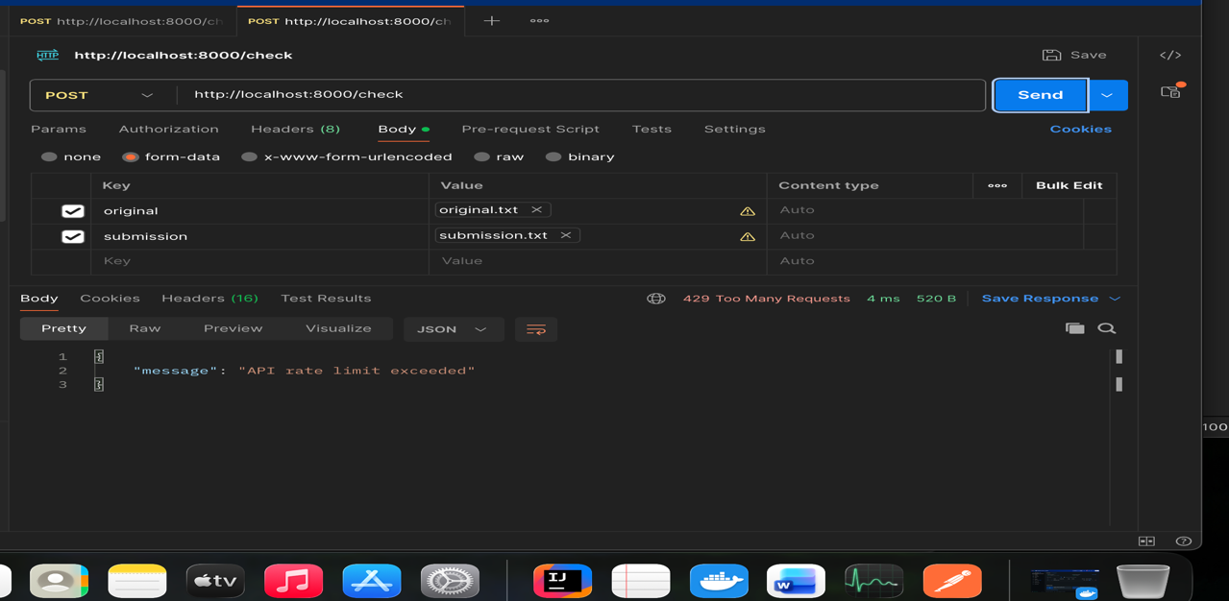

Request file Size Limit.

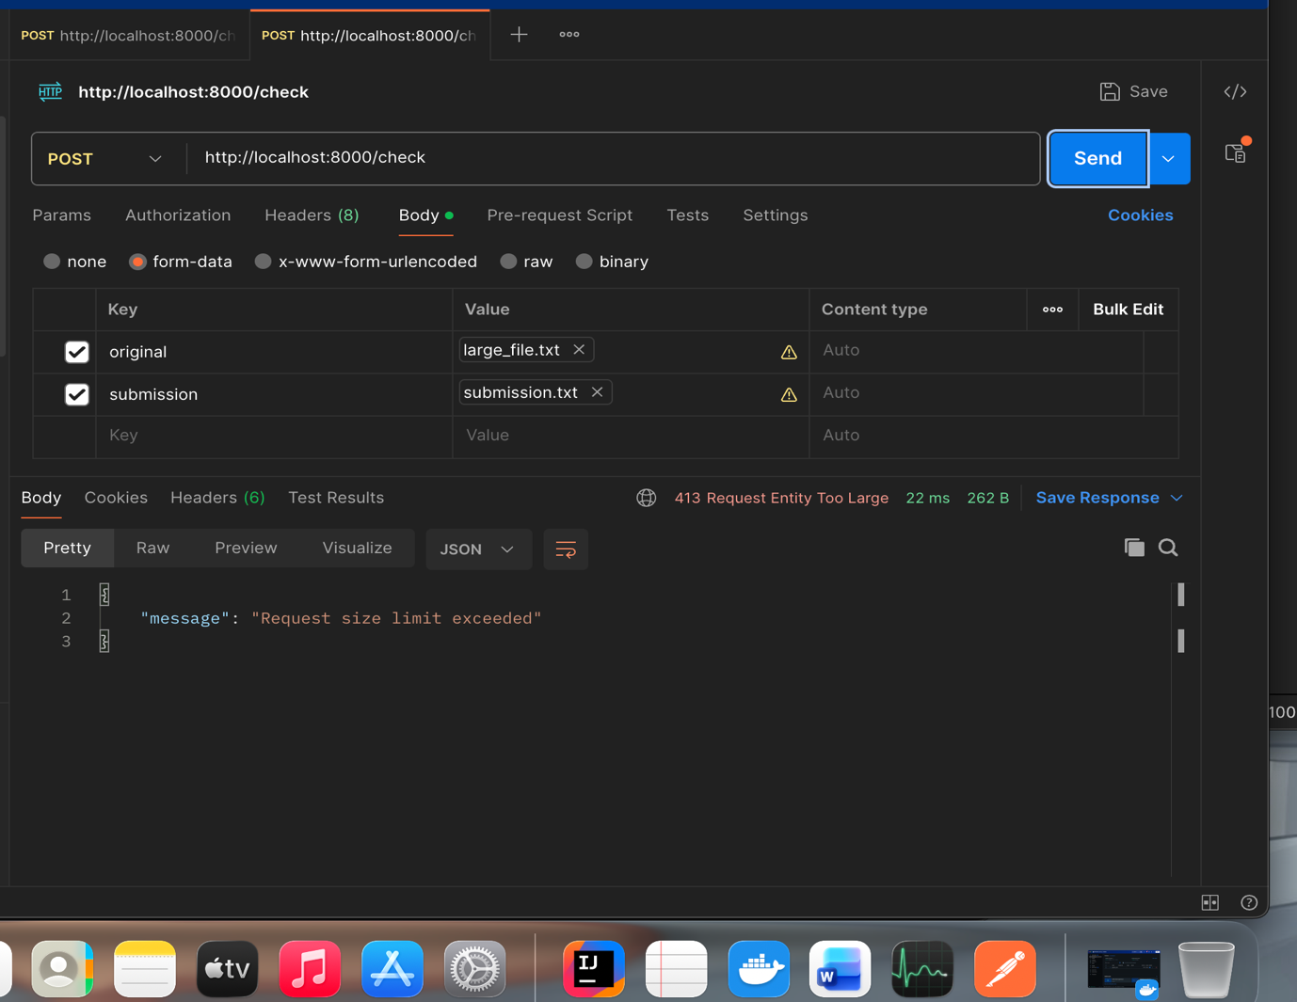

Plagiarism Success check

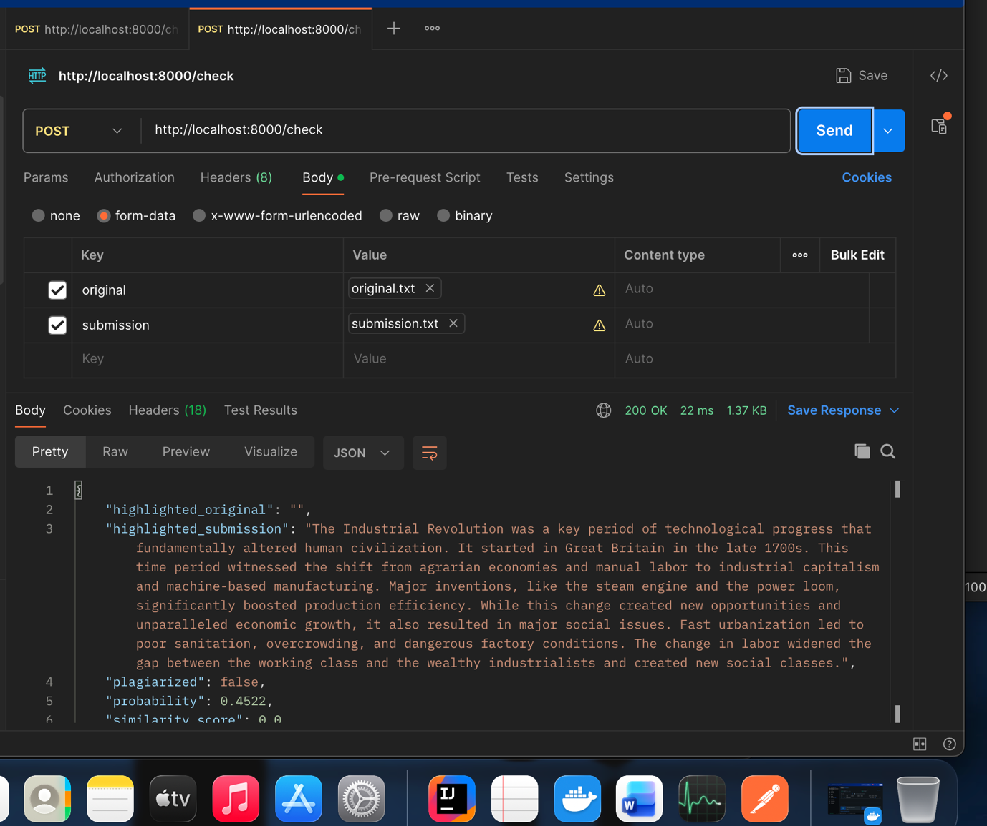

From the Kong Admin screen we can see added gateway Routes and Plugins.

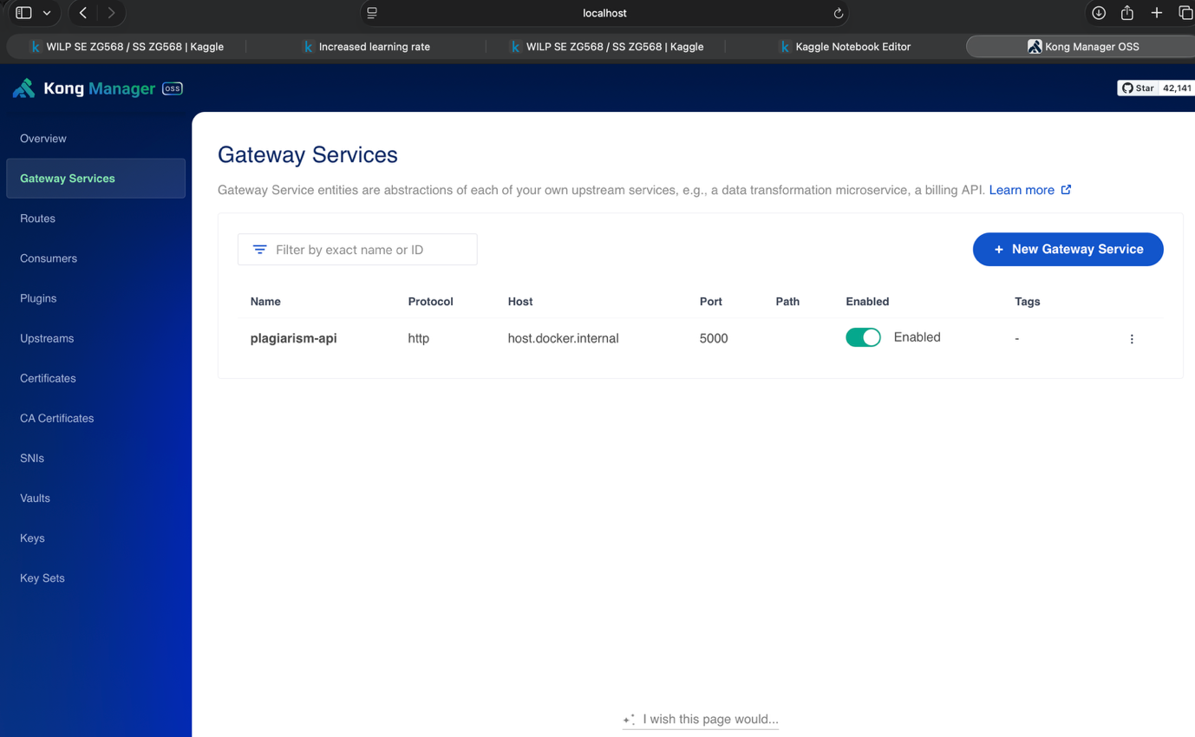

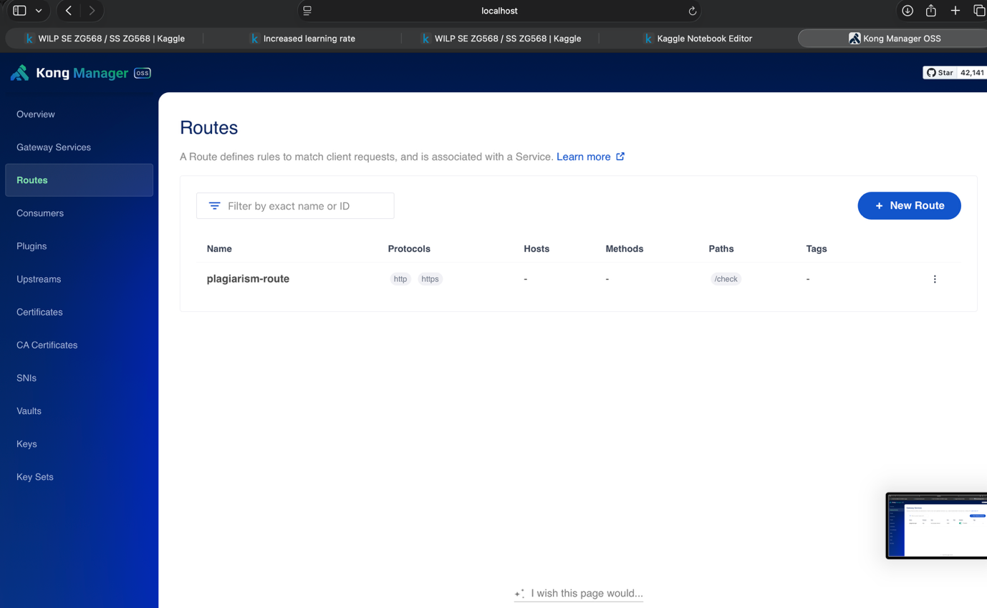

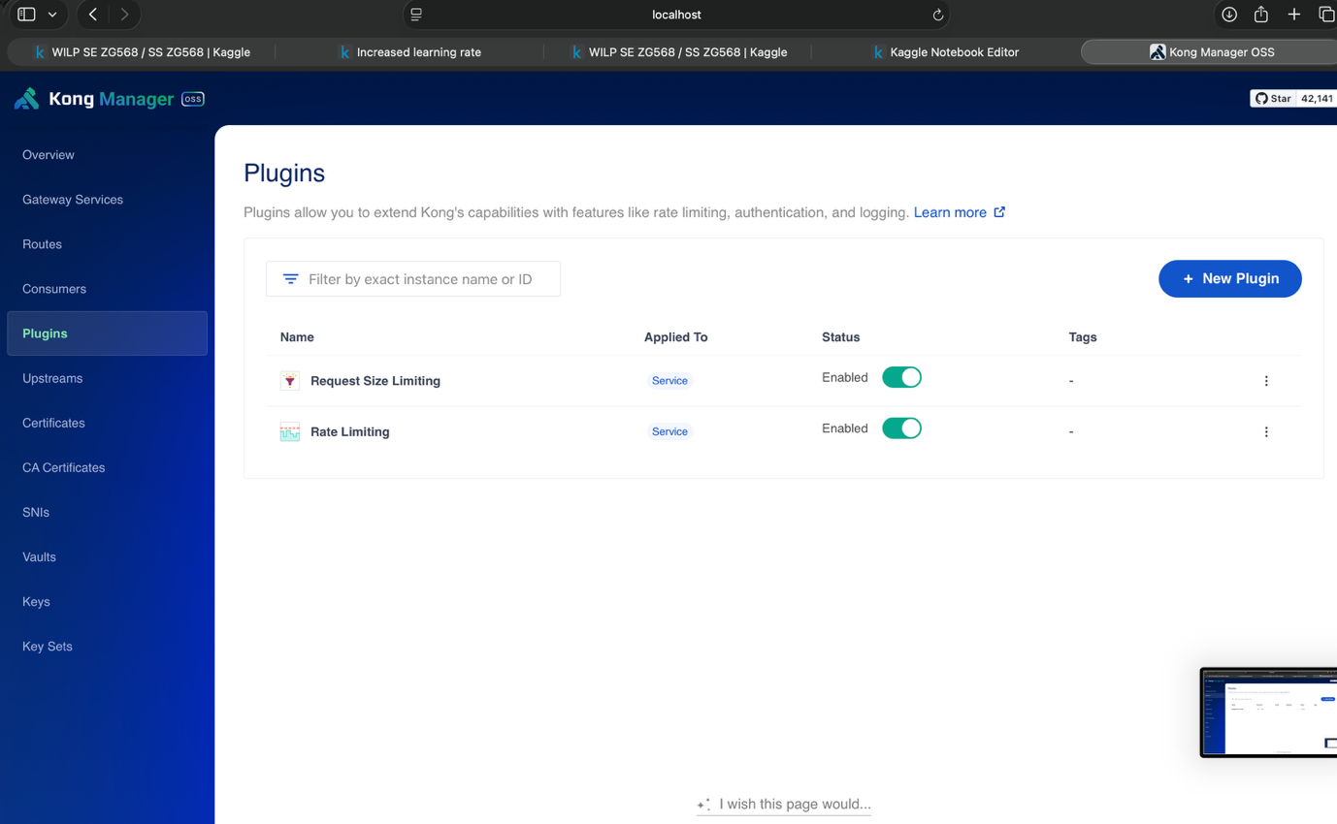

**Question 3: Implement TokenBucket and Leaky Bucket Rate Limiting Algorithm.**